**Analysis of Airport Data using Hadoop-Hive**

1. **creating table airport for airports_mod.dat**:

create table airport (Airport_ID string,Name string,City string,Country string,IATA_FAA string,ICAO string,Latitude string,Longitude string,Altitude string,Timezone string,DST string,TZ string) row format delimited fields terminated by ',';



2.**creating table finalairlines for Final_airlines** :

create table finalairlines(Airline string,Name string,Alias string,IATA string,ICAO string,Callsign string,Country string,Active string) row format delimited fields terminated by ',';



3. **Creating table route for routes.dat**:

create table route(Airline string,Airline_ID string,Source_airport string,Source_airport_ID string,Destination_airport string,Destination_airport_ID string,Codeshare string,Stops string,Equipment string) row format delimited fields terminated by ',';

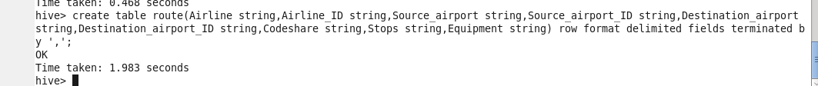

4. **loading data into airport table**

load data local inpath '/home/edureka/rahul/project_datasets/airport' into table airport;

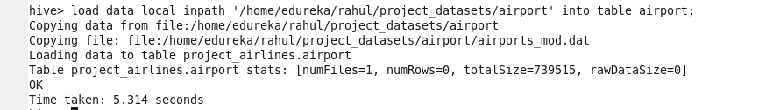

5. **loading data into finalairlines table**

load data local inpath '/home/edureka/rahul/project_datasets/finalairlines' into table finalairlines;



6**.loading data into route table**

load data local inpath '/home/edureka/rahul/project_datasets/route' into table route;

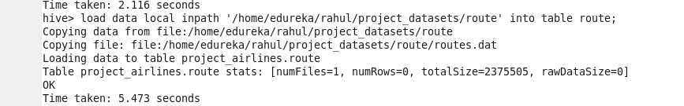

**Problem solution**:

a) **Find list of Airports operating in the Country India**;

create table india_opert_airport as select * from airport where Country LIKE '%India%';

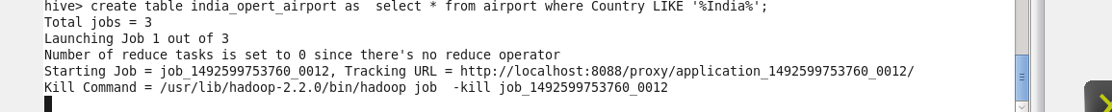

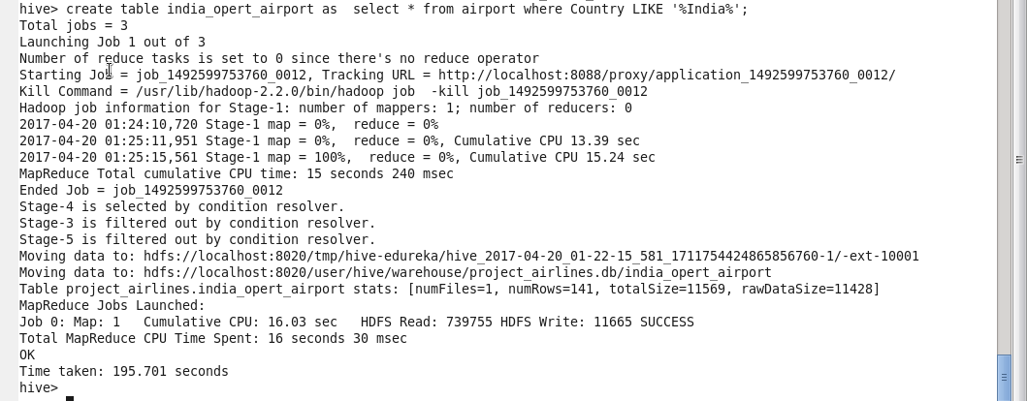

select * from india_opert_airport limit 10; (to show only first 10 values due to large nos of data)

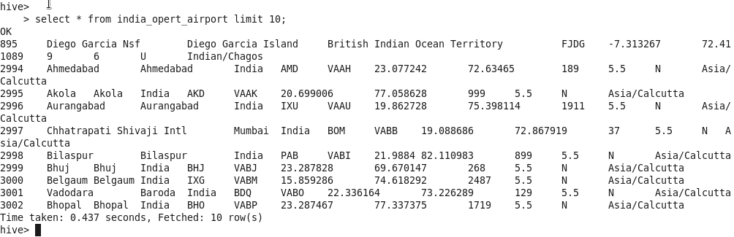

b.**Find the list of Airlines having zero stops**

create table stop as select * from route where Stops LIKE '%0';

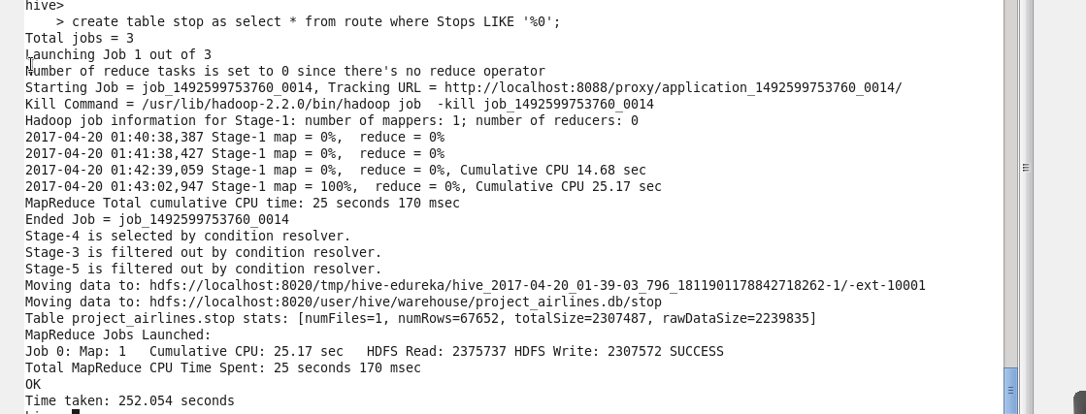

select * from stop limit 10;

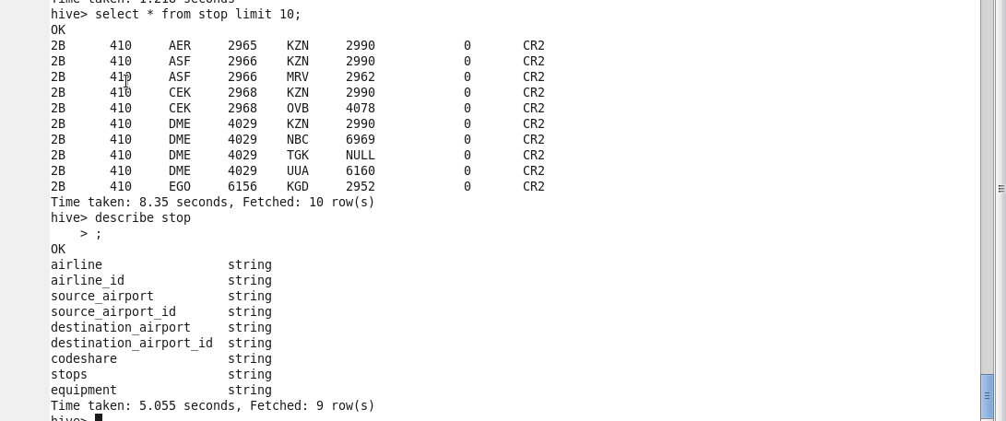

**c.List of Airlines operating with code share**

create table codeshare_1 as select * from route where Codeshare LIKE '%Y%';

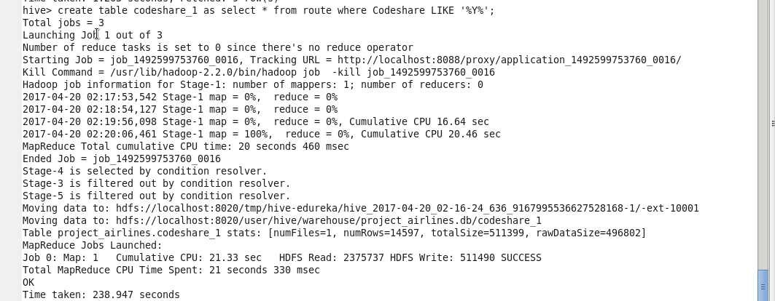

select * from codeshare_1 limit 10;

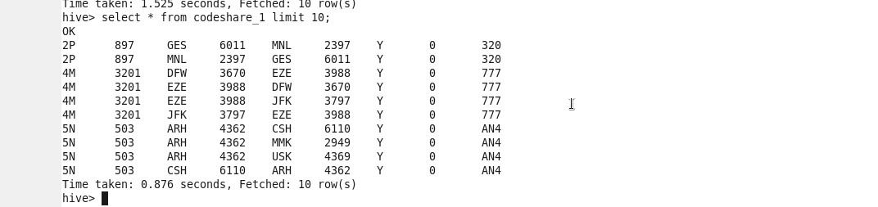

**d.Which country (or) territory having highest Airports**

select Country,count(*) as cnt from airport group by Country SORT BY cnt DESC;

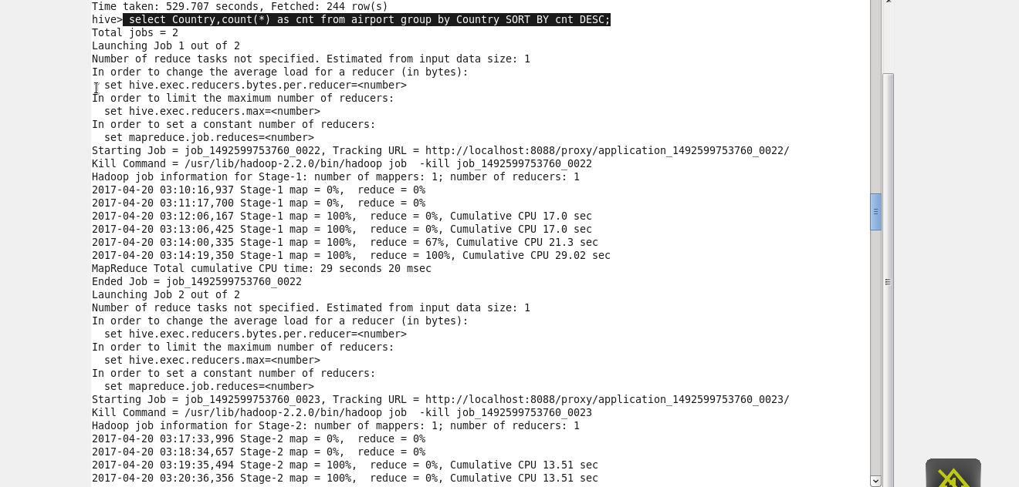

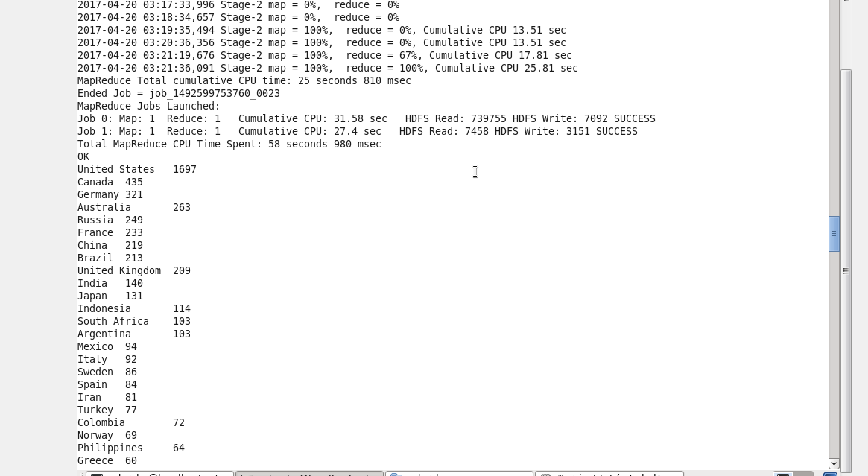

**E. Find the list of Active Airlines in United state**

select * from finalairlines where Country like '%United States%' AND Active like '%Y%';

